Bug with google map 20120220

Normal procedure
Once the server has processed its job it must print on the screen a map.

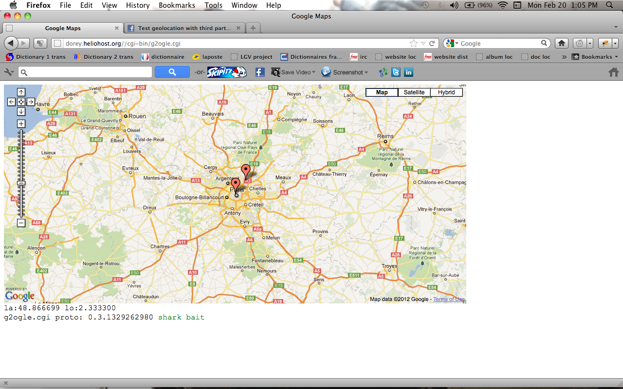
Results expected

Now if we look at the code received we must have something like:

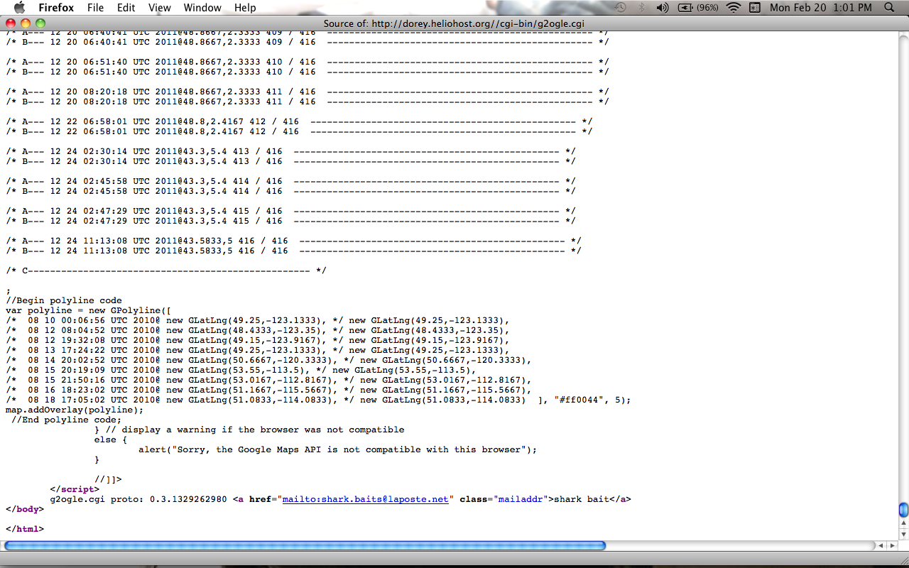
Code returned when everything is ok
(begining of the code skiped)

Now here is a little explanation of the mecanism
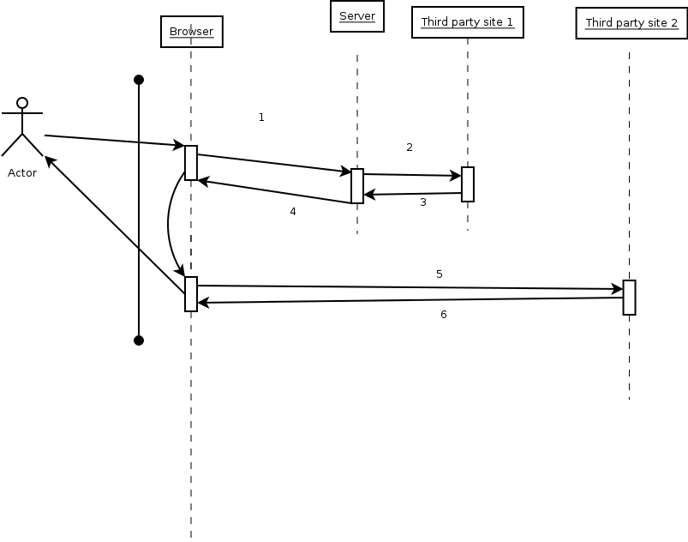
Basic mecanism

A user (Actor) use a browser (the first object). He ask for a service (drawing a map with a data base not represented on the drawing). The browser launch the server (1). The server build the code but wait for an anwser on a distant website (geolocation coordinate from the current IP address).
That'd the link (2) and the result is in (3). Hence te code is sent to the browser (4). The browser interprets the code received. It connects to googlemap to print information (5). Then results is printed (6) on the browser. It should be a map with the coordinates located (6).

The problem
The is a cut somewhere and the code is not fully received. See the pictures below:
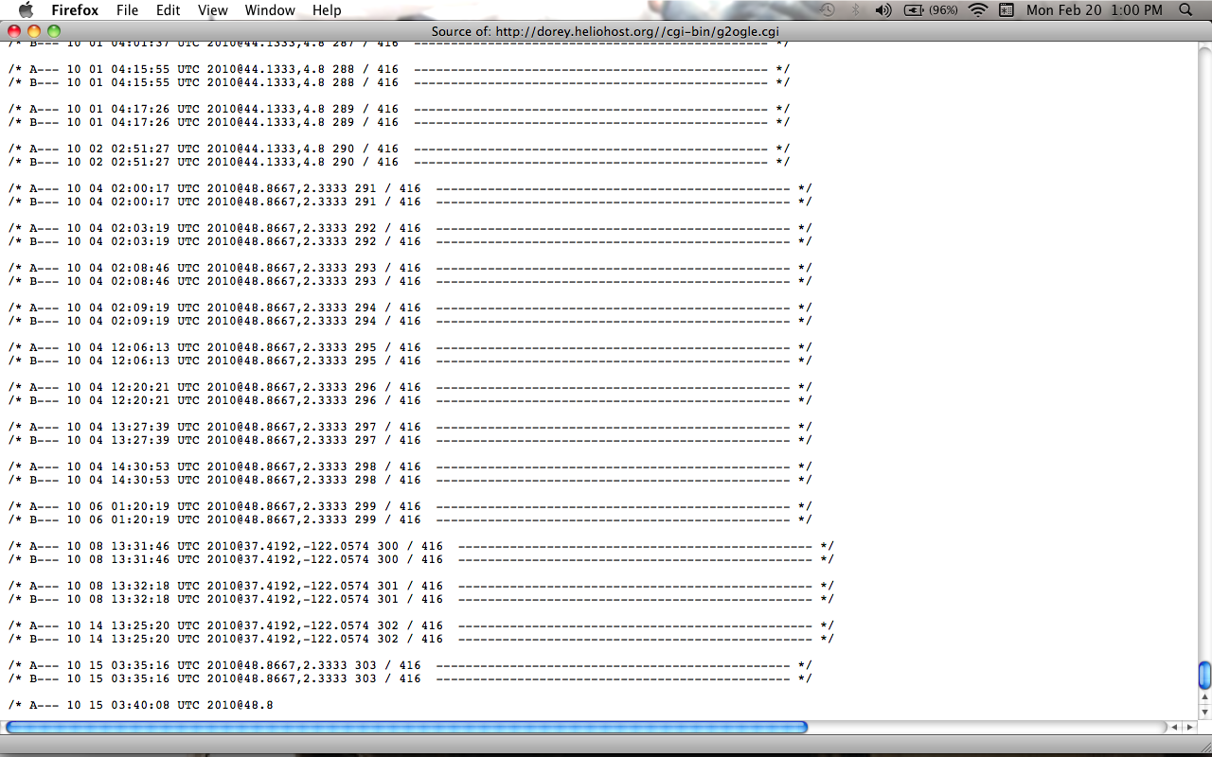
Peace of code not the whole code

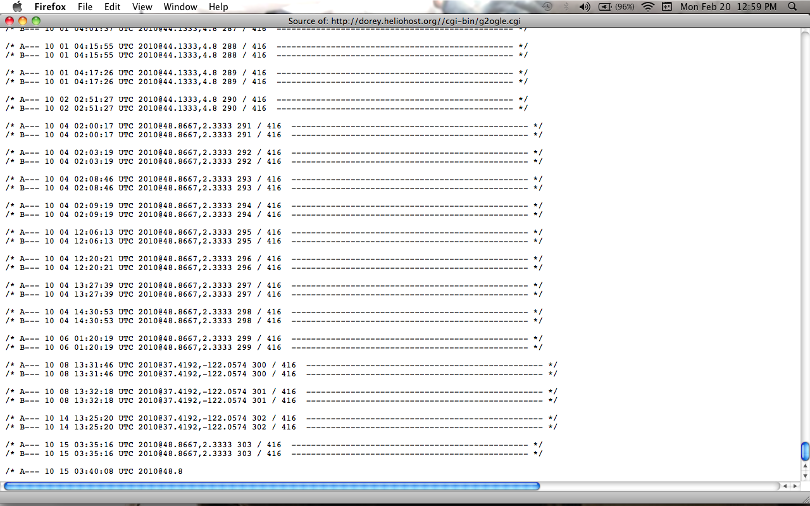
peace of code received

From these we can think of a bug. But where?

